Lecture Handout: Securing Applications with OpenID Connect (OIDC)
One of the selling points of a web framework like ASP.NET Core is the ability to provide a dynamic app, customized to individual users. Many apps have the concept of an “account” with the service, which you can “sign in” to and get a different experience. Depending on the service, an account gives you varying things: on some apps you may have to sign in to get access to additional features, on others you might see suggested articles. On an e-commerce app, you’d be able to make and view your past orders, on Stack Overflow you can post questions and answers, whereas on a news site you might get a customized experience based on previous articles you’ve viewed. When you think about adding users to your application, you typically have two aspects to consider:
1. Core Concepts: Authentication vs. Authorization
Security in any application requires two distinct mechanisms:
- Authentication: Identifying the user attempting to perform actions. It is the process of creating users and letting them log in to your app. (who you are)
- Authorization: Allowing specific privileges or actions to be given to an already authenticated user. This also allows customizing the experience and controlling what users can do, based on the current logged-in user. (what you’re allowed to do)
2. OAuth 2.0 : Is an authorization protocol. A protocol (in computing and networking) is simply a set of rules that define how systems communicate with each other.
OAuth 2.0 Flow (Simplified)
- User clicks Login with (Google, Facebook, )
- Client redirects user to authorization server
- User logs in & gives consent
- Authorization server returns authorization code
- Client exchanges code for access token
- Client uses token to access API (resource server)

3. Introduction to OpenID Connect (OIDC)
OpenID Connect (OIDC) is an identification standard built on top of the OAuth 2.0 authorization protocol. Its primary goal is to delegate user authentication to a trusted third-party service, such as Google, Facebook, Apple, or Microsoft.
This follows the Single Sign-On (SSO) principle, where a single authentication system is reused across multiple applications. The interaction involves three actors:
- The Client: The application (e.g., a web app).
- The Identity Provider (IdP): The service that verifies the user's identity.
- The Protected Resource: The API or data being accessed.
4. The JSON Web Token (JWT)
When a user authenticates with the IdP, the provider issues a JSON Web Token (JWT).
- Structure: A JWT is encoded in Base64 and consists of three parts separated by dots: Header, Content (Payload), and Signature.
- Validation: The application validates the token autonomously by retrieving metadata from the identity provider only once. It uses a key to verify the signature, ensuring the token was issued by the correct provider and has not been tampered with.
- Claims: The content of the token contains "claims," which are key-value pairs defining the user's identity, email, and assigned roles.
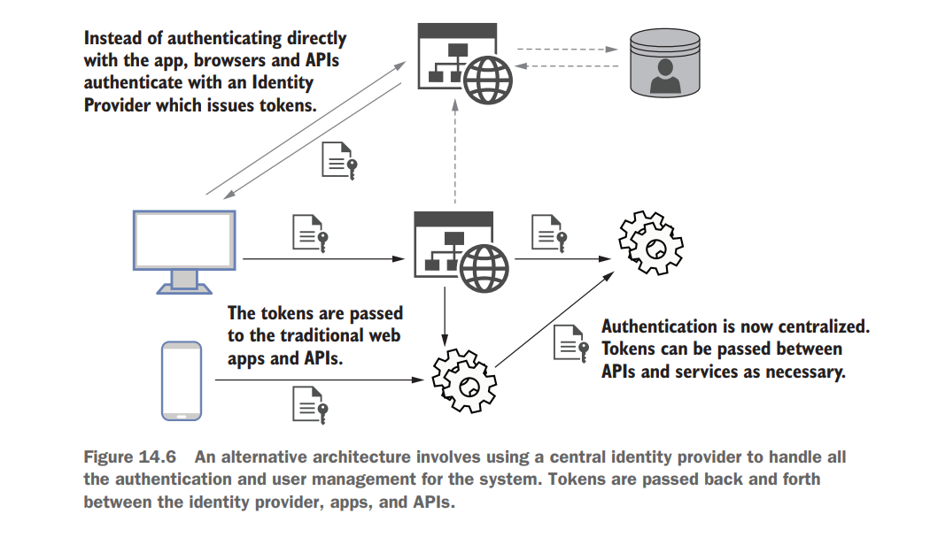
5. Configuring ASP.NET Core Security
To secure an API, you must configure the server to recognize and trust the JWTs issued by your chosen IdP.
- Installation: Install the NuGet package: Microsoft.AspNetCore.Authentication.JwtBearer.
Tools → NuGet Package Manager → Package Manager Console
Then write “Install-Package Microsoft.AspNetCore.Authentication.JwtBearer” in the console window. Check that Dependencies → Packages contains the package.
Then to use it add using Microsoft.AspNetCore.Authentication.JwtBearer; to your Program.cs code.
B. Configuration (Program.cs): You must define how the application validates incoming tokens:
- AddAuthentication: Defines the authentication scheme (usually JwtBearer).
- AddJwtBearer: Sets the parameters for trust:
  - Authority: The URL of the identity provider.
  - Audience: The unique identifier for your application.
  - ValidateLifetime & ValidateIssuer: Set to true to ensure the token is current and from the right source.
  - ClockSkew: Manages the time gap (usually 5 minutes) between the IdP's clock and your server's clock to prevent accidental rejection of valid tokens.
C. The Middleware Pipeline: The order of middleware is critical. UseCors must be placed before authentication and authorization:
- app.UseCors();
- app.UseAuthentication(); (Registers the auth middleware).
- app.UseAuthorization(); (Activates authorization rules).
6. Protecting Endpoints and Identifying Users
- Restricting Access: Use the .RequireAuthorization() extension method on minimal endpoints to ensure only authenticated users can access them.
- Role-Based Security: You can define policies (e.g., "SurveyCreator") that require a user to have a specific role claim within their JWT to access a resource.
- Handling Errors:
  - 401 Unauthenticated: The user does not have a valid JWT.
  - 403 Forbidden: The user is authenticated but lacks the necessary roles/permissions.
- Accessing Identity: You can inject the ClaimsPrincipal class into your endpoints to read the user's claims directly from the token. For cleaner code, you can design a UserProfile service that uses IHttpContextAccessor to expose user data like names and roles.
7. Passing the Token
For every request to a protected resource, the client must pass the JWT in the HTTP header as follows:
Authorization: bearer {YourJWT}

